Collateral Web

TFS 92351 – Enhance scenarios for object ownership;

TFS 92357 – Multiple Collateral Scenarios

Feature Overview

92351: Objects “owned” by a scenario not visible to other scenarios. Some situations require multiple scenarios for the same customer (branch is working PCA loans while Lending Operations is working on FLCA loans; loans may be booked at different times and be at different stages). User is unable to see which objects are “owned” by which scenario; if they inadvertently make a change in an object “owned” by another scenario, CW locks up, FPI has to script out the scenario and we start over. This typically happens on complex relationships.

92357: Goal is to reduce the number of multiple collateral scenarios. It is probably infrequent that staff would want to create multiple scenarios for the same group of loans. Would like a warning if possible.

# Document Change History

|  |  |  |  |  |
| --- | --- | --- | --- | --- |
| Version | Date Changed | Description | Approved By | Date Approved |
| 1 | 08/26/16 | Document started | Rebeca McFarland | 08/26/16 |
| 2 | 09/08/16 | Updated mock-ups and other edits | Bevin Morrissey | 09/08/16 |
|  |  |  |  |  |
|  |  |  |  |  |
|  |  |  |  |  |

FPI Credit Products

September 8, 2016

Table of Contents

Collateral Web 1

Document Change History 1

Statement of the Problem 2

FPI Recommendation 3

Creating a New Scenario 3

Submitting Scenarios to EmPOWER 6

TFS 92351 – Enhance scenarios for object ownership; TFS 92357 – Multiple Collateral Scenarios

## Statement of the Problem

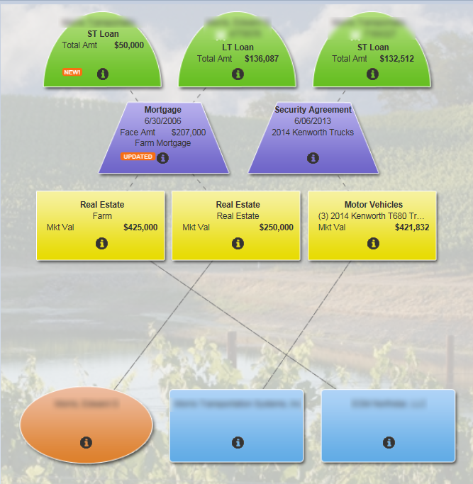

**Employee #1** wants to work on the **short and long term loans** on the left side of the picture (scope #1) in Scenario #1.

**Employee #2** wants to work on the **short term loan** on the right side of the picture (scope #2) in Scenario #2.

If one of these two employees updates collateral belonging to a loan in the opposite scope, the two scenarios become entangled and FPI has to manually clean up data in the database with a script.

We would like to make it more obvious which collateral objects belong to which scope, and make it more difficult to lock up scenarios by creating multiple scenarios that include the same scope.

## FPI Recommendation

### Creating a New Scenario

When you start a new scenario, the app will ask you which scope/loans you want to include in your new scenario.

* If a scenario already exists for a particular scope, an alert will fire to tell you.
* Identified scopes in the scenario are pinned; all other scopes are grayed out.
* You will have to start a new scenario to work on any of the other scope(s) that you did not initially include.
* If multiple scenarios exist for a particular scope, when you go to submit any one of them to EmPOWER, an alert will warn you that all other scenarios for this scope will be **deleted**.
  + If you decide to continue and submit your scenario to EmPOWER, then all other scenarios for that scope, or that include that scope, are deleted.

If you need to add scopes to your scenario, then you can copy the scenario and select additional scopes at the time of creation.

In our example, for **Employee #1** who is working on the **short and long term loans** on the left side of the picture (scope #1) in Scenario #1, this means that scope #2, the short term loan on the right and its associated collateral objects, is grayed out.

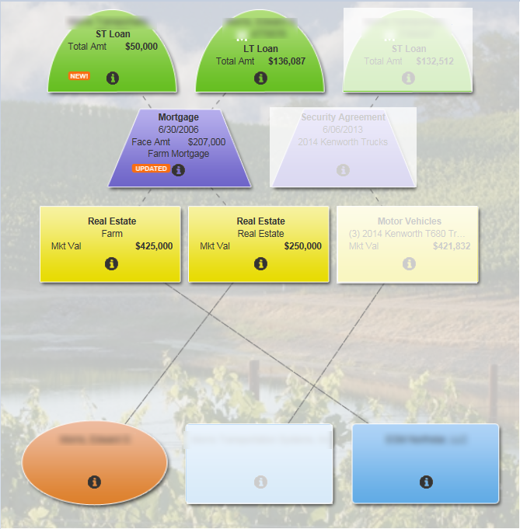

Employee #1 can still see the objects in scope #2, but they will not have the ability to make changes to the scope #2 objects from within Scenario #1.

If Employee #1 needs to work on any items in scope #2, they can either do so from within Scenario #2 (which includes scope #2), or a new scenario has to be created.

If they wish to create a new scenario, Employee #1 would then copy Scenario #1 to create Scenario #3.

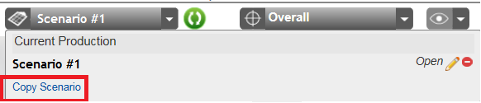

As they do so, they will select the scope(s) that they would like to be included in Scenario #3.

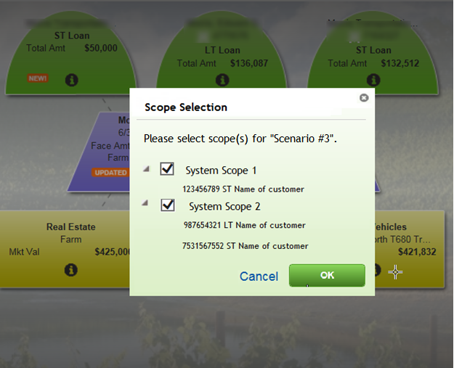

If they include scope #2, which is already included in another scenario, the following alert appears:

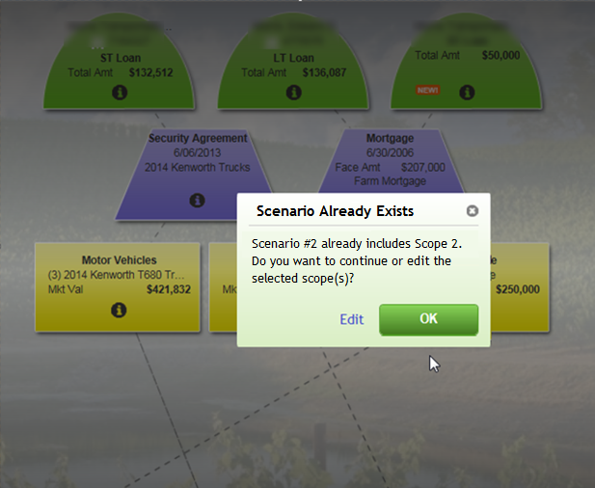

* Clicking “OK” means the new scenario will be created and they can now work on all objects from across all scopes in the new scenario.
* Selecting “Edit” will send them back to the Scope Selection modal for the new scenario.

For customers with multiple scopes, a scrollbar will allow scrolling between all available scopes.

### Submitting Scenarios to EmPOWER

By submitting a scenario to EmPower, all OTHER scenarios that include the same scopes as those included in the scenario being submitted will be **DELETED**.

For example, if you were to submit Scenario #2 from the above example, which includes scope #2, Scenario #3 would be deleted, as it also includes scope #2.

This is consistent with how the application works today.